Getting Started with Docker on Windows SOP



Table of Contents

1. Getting Started with Docker on Windows 3
1.1 Description 3
1.2 Architecture Diagram 3
1.3 Lab Steps 4
1.4 Troubleshooting 4
1.5 Supporting References 4

Getting Started with Docker on Windows

Description
Containers are becoming the new normal. Docker is one of the container platform, where user can create containers. Docker is available in all major OS. In this lab exercise, installation of docker and running a sample container are demonstrated.

Architecture Diagram
The diagram below displays a visual representation of the underlying application architecture:

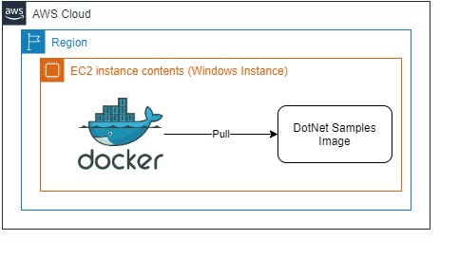

Lab Steps
- Create an EC2 Instance (Windows Server 2019 Base). Make sure to attach the following IAM Role CCLEC2-Role. Only then RDP is possible with Sessions Manager.
- Enter the following commands to install Docker:
  - Install-Module -Name DockerMsftProvider -Repository PSGallery -Force
  - Install-Package -Name docker -ProviderName DockerMsftProvider
  - Enter “Y” for all the prompts
  - After installing, enter the following command to restart the prompt: Restart-Computer -Force. This command will terminate the current session.
  - Connect again to the Instance via Sessions Manager
  - Enter the following command to check if Docker is properly installed: docker version
  - Enter the following command to check information about docker: docker info
- Pull a sample docker repository:
docker pull microsoft/dotnet-samples
- Run the pulled image:
docker run microsoft/dotnet-samples:dotnetapp-nanoserver-1809
If everything is successful, the above-mentioned command should print an output.

Troubleshooting
S. No | Problem |  | Solution
1 | Not able to Connect via Sessions Manager | • | Make sure that the role CCL-EC2Role is attached to the instance.
 |  | • | Try to stop and start the instance.
 |  | • | Wait for 6 -12 minutes and try again.

Supporting References
Refer the below links for additional information:

- https://www.jorgebernhardt.com/how-to-install-docker-on-windows-servers/
- https://docs.docker.com/docker-for-windows/
